Name: Adnan Aslam
Roll no: 25CS018 (SEC2)

Department of: |  | Subject of:
Computer Systems Engineering |  | Object Oriented Programming
Mehran University of Engineering &Technology |  | Year | 1ST | Semester | 2ND
 |  | Batch | 25CS | Duration | 03  Hours
Jamshoro
Practical # 4
To practice programs using Arrays and String manipulations
Objectives
To practice programs using Arrays and String manipulations.
Tools
Notepad++/IntelliJ Idea/Eclipse IDE
Keywords: array and string. | Duration:03 hours

Exercise
Problem Statement 1
Write a program that prompts the user to provide fifteen integers, each between 10 and 50. When each integer is read, program displays it only if it is not the duplicate of already provided numbers. Moreover, program should display “Wow‼! All the numbers are unique”, if all the fifteen integers are unique.
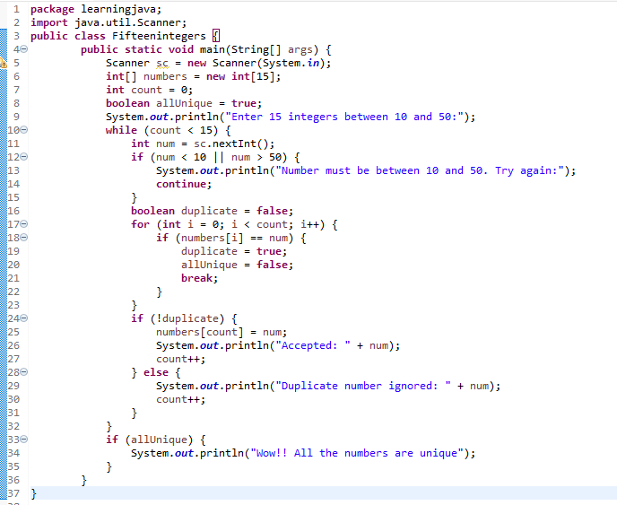
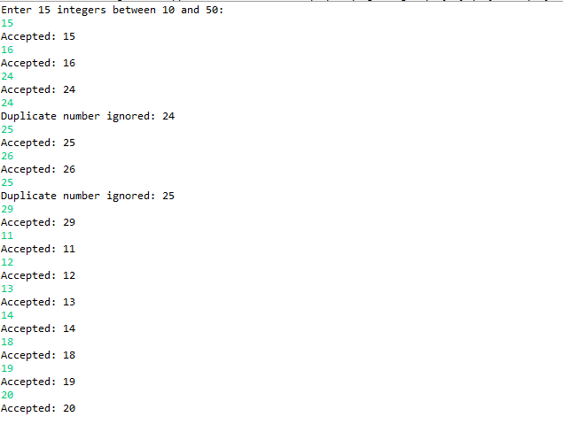
Problem Statement 2
Write a program that find the common elements between any two given arrays.
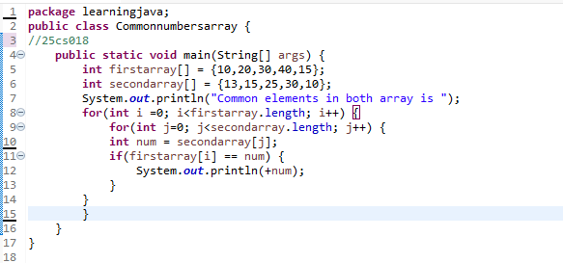
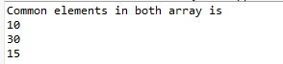
Problem Statement 3
Write a program that takes a 2*2 matrix as input and converts all the negative elements of the given array to zero.
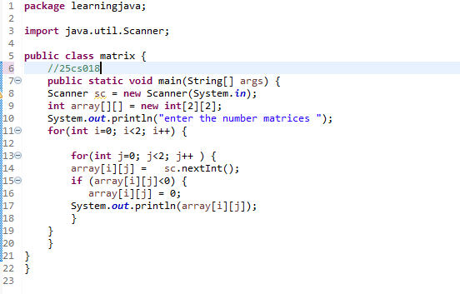
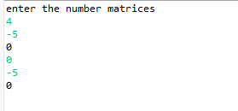
Problem Statement 4
Write a program that asks the user to enter a 2×2 matrix. Display the transpose of the matrix.
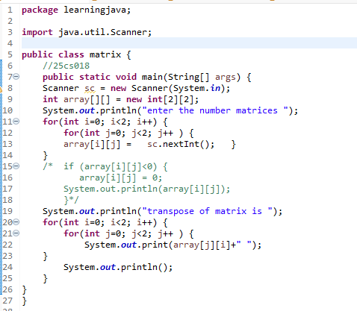
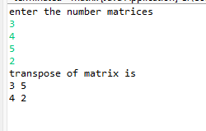
Problem Statement 5
Write a program that takes a string as input and displays the first half of the string. a. For example, "HelloThere"→ "Hello" and "abcdef" → "abc"
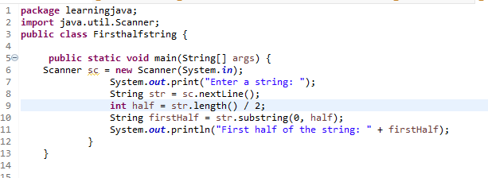
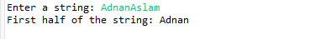

Problem Statement 6
Write a program that asks the user to provide his/her CNIC number and checks whether the given CNIC number is valid or not. A valid CNIC number contains 13 numerical digits and two times hyphen (-); one hyphen is placed after five digits and the other one after 12 digits.
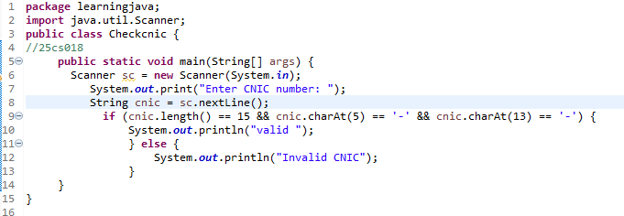
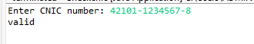

Lab Rubrics

Course code: |  | CS-153 |  | Course Name: |  |  | Object Oriented Programming
Lab 03: | To practice programs using Arrays and String manipulations
Roll No:25cs018 |  |  |  | Student Name: |  |  | Adnan Aslam
Batch: | 25 |  | Section: |  | 2 | Group: |  |  | Date:

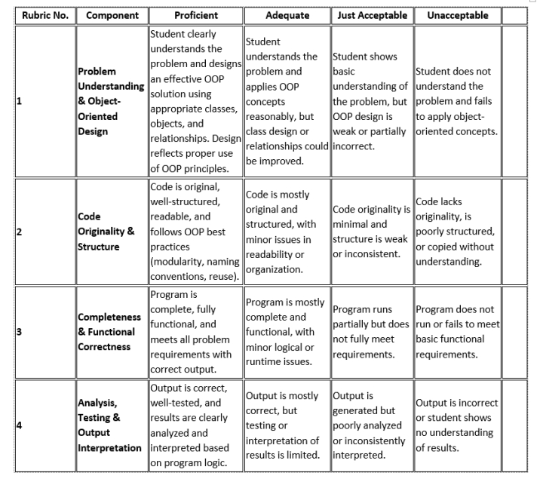
Teacher: Date:

